**Pizza Sales SQL queries**

**A. KPI’S:**

1. *Total Revenue: The sum of total price of pizzas orders.*

SELECT SUM(total_price) AS Total_Revenue FROM pizza_sales;

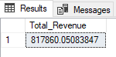

*2. Average Order Value: The average amount spent per order, calculated by dividing the total number of orders.*

SELECT SUM(total_price) / COUNT(DISTINCT order_id) AS Average_Order_Values FROM pizza_sales;

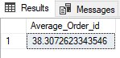

*3. Total Pizzas Sold: The total sum of quantities of all pizzas sold.*

SELECT SUM(quantity) AS Total_Pizza_sold FROM pizza_sales

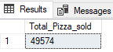

*4. Total Orders Placed: The count of all the orders placed by the customers.*

SELECT COUNT(DISTINCT order_id) AS Total_Orders FROM pizza_sales

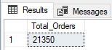

*5. Average Pizzas per Order: The average numbers of pizzas sold per order, calculated by dividing the total numbers of pizzas sold by the total number of orders.*

SELECT CAST(CAST(SUM(quantity) AS DECIMAL (10,2))/CAST(COUNT(DISTINCT order_id) AS DECIMAL (10,2))AS DECIMAL (10,2)) AS Avg_Pizzas_per_Order FROM pizza_sales

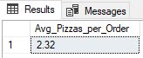

**B. Daily trend for Total orders:**

*1. Create a bar chart that displays the daily trend of total orders over a specific time period. This chart will help us to identify any patterns or fluctuations in the order volume on a daily basis.*

SELECT DATENAME(DW, order_date) as Order_days, COUNT(DISTINCT order_id) AS Total_orders

FROM pizza_sales

GROUP BY DATENAME(DW, order_date)

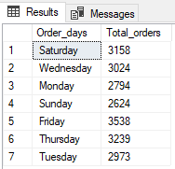

*\*\* Total orders arranged with respect to Days from Sunday to Saturday*

SELECT DATENAME(DW, order_date) as Order_days, COUNT(DISTINCT order_id) as Total_orders

FROM pizza_sales

GROUP BY DATENAME(DW, order_date)

ORDER BY CASE WHEN DATENAME(DW, order_date) = 'Sunday' then 1

WHEN DATENAME(DW, order_date) = 'Monday' then 2

WHEN DATENAME(DW, order_date) = 'Tuesday' then 3

WHEN DATENAME(DW, order_date) = 'Wednesday' then 4

WHEN DATENAME(DW, order_date) = 'Thursday' then 5

WHEN DATENAME(DW, order_date) = 'Friday' then 6

WHEN DATENAME(DW, order_date) = 'Saturday' then 7

ELSE NULL END

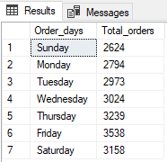

**C. Monthly Trend for Orders:**

*1. Create a line chart that illustrates the hourly trend of total orders throughout the day. The chart will allow us to identify peak hours or periods of high order activity.*

SELECT DATENAME(MONTH, order_date) as Month_names, COUNT(DISTINCT order_id) as Total_orders

FROM pizza_sales

GROUP BY DATENAME(MONTH, order_date)

ORDER BY Total_orders DESC

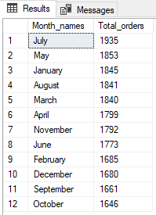

**D. Percentage of Sales by Pizza categories:**

*1. Create a pie chart that shows the distribution of sales across different pizza categories. This chart will provide insights into the popularity of various pizza categories and their contributions to overall sales.*

SELECT pizza_category, SUM(total_price) AS Total_Sales, SUM(total_price) * 100 / (SELECT SUM(total_price) FROM pizza_sales)

AS Perctg_Sales

FROM pizza_sales

GROUP BY pizza_category

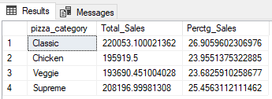

*\*\* In order to filter this data according to each month:*

SELECT pizza_category, CAST (SUM(total_price) AS DECIMAL (10,2)) AS Total_Sales, CAST (SUM(total_price) * 100 /

(SELECT SUM(total_price) FROM pizza_sales WHERE MONTH(order_date) = 1) AS DECIMAL (10,2))

AS Perctg_Sales

FROM pizza_sales

WHERE MONTH(order_date) = 1

GROUP BY pizza_category

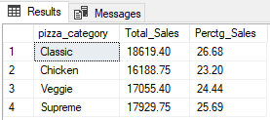

**E. Percentage of Sales by Pizza sizes:**

*1. Generate a pie chart that represents the percentage of sales attributed to different pizza sizes. This chart will us to understand customer’s preferences for pizza sizes and their impact on sales.*

SELECT pizza_size, CAST(SUM(total_price) AS DECIMAL (10,2)) AS Total_Revenue,

CAST (SUM (total_price) * 100 /

(SELECT SUM (total_price) FROM pizza_sales)AS DECIMAL (10,2)) AS Perctg_Sales

FROM pizza_sales

GROUP BY pizza_size

ORDER BY pizza_size

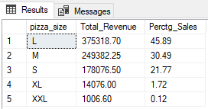

**F. Total Pizza Sold by Pizza Catagory:**

*1. Create a funnel chart that represents the total number of pizza sold for each pizza category. This chart will allow us to compare the sales performance of different pizza categories.*

SELECT pizza_category, SUM (quantity) AS Total_Qty_Sold

FROM pizza_sales

GROUP BY pizza_category

ORDER BY pizza_category

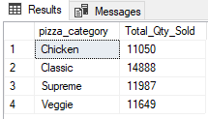

**G. Top 5 best seller by Revenue, Total quantity and Total orders:**

*1. Create a bar chart highlighting the top 5 bestselling pizzas based on the revenue, total quantity, total orders. This chart will help us to identify the most popular pizza options.*

*(i) Top 5 category of pizzas w.r.t Revenue*

SELECT TOP 5 pizza_name, CAST(SUM(total_price) AS DECIMAL(10,3)) AS Total_Revenue

FROM pizza_sales

GROUP BY pizza_name

ORDER BY Total_Revenue DESC

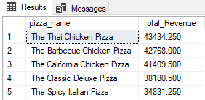

*(ii) Top 5 category of pizzas w.r.t Quantity*

SELECT TOP 5 pizza_name, CAST(SUM(quantity) AS DECIMAL(10,3)) AS Total_Quantity

FROM pizza_sales

GROUP BY pizza_name

ORDER BY Total_Quantity DESC

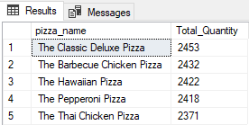

*(iii) Top 5 category of pizzas w.r.t Orders*

SELECT TOP 5 pizza_name, COUNT(DISTINCT order_id) AS Total_Orders

FROM pizza_sales

GROUP BY pizza_name

ORDER BY Total_Orders DESC

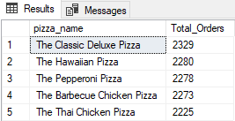

**H. Bottom 5 best seller by Revenue, Total quantity and Total orders:**

*1. Create a bar chart highlighting the top 5 bestselling pizzas based on the revenue, total quantity, total orders. This chart will help us to identify the most popular pizza options.*

*(i) Top 5 category of pizzas w.r.t Revenue*

SELECT TOP 5 pizza_name, CAST(SUM(total_price) AS DECIMAL(10,3)) AS Total_Revenue

FROM pizza_sales

GROUP BY pizza_name

ORDER BY Total_Revenue ASC

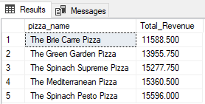

*(ii) Top 5 category of pizzas w.r.t Quantity*

SELECT TOP 5 pizza_name, CAST(SUM(quantity) AS DECIMAL(10,3)) AS Total_Quantity

FROM pizza_sales

GROUP BY pizza_name

ORDER BY Total_Quantity ASC

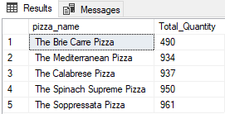

*(iii) Top 5 category of pizzas w.r.t Orders*

SELECT TOP 5 pizza_name, COUNT(DISTINCT order_id) AS Total_Orders

FROM pizza_sales

GROUP BY pizza_name

ORDER BY Total_Orders

